

National Textile University
Department of Computer Science
Subject: Operating system

Submitted to: Sir Nasir

Submitted by: Maha

Reg. number: 23-NTU-CS-1170
Lab 10 (Home task)
Semester:5th

Task1:
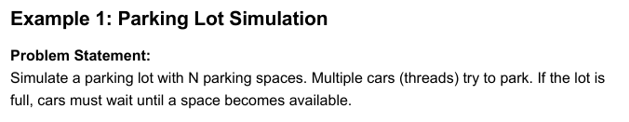
Code:
// Problem Statement:
// Simulate a parking lot with N parking spaces. Multiple cars (threads) try to park. If the lot is
// full, cars must wait until a space becomes available
#include <stdio.h>
#include <pthread.h>
#include <semaphore.h>
#include <unistd.h>
sem_t parking_spaces;
void* car(void* arg) {
int id = *(int*)arg;
printf("Car %d is trying to park...\n", id);
sem_wait(&parking_spaces); // Try to get a space
printf("Car %d parked successfully!\n", id);
sleep(2); // Stay parked for 2 seconds
printf("Car %d is leaving.\n", id);
sem_post(&parking_spaces); // Free the space
return NULL;
}
int main() {
pthread_t cars[10];
int ids[10];
// Initialize: 3 parking spaces available
sem_init(&parking_spaces, 0, 3);
// Create 10 cars (more than spaces!)
for(int i = 0; i < 10; i++) {
ids[i] = i + 1;
pthread_create(&cars[i], NULL, car, &ids[i]);
}
// Wait for all cars
for(int i = 0; i < 10; i++) {
pthread_join(cars[i], NULL);
}
sem_destroy(&parking_spaces);
return 0;
}

Terminal:

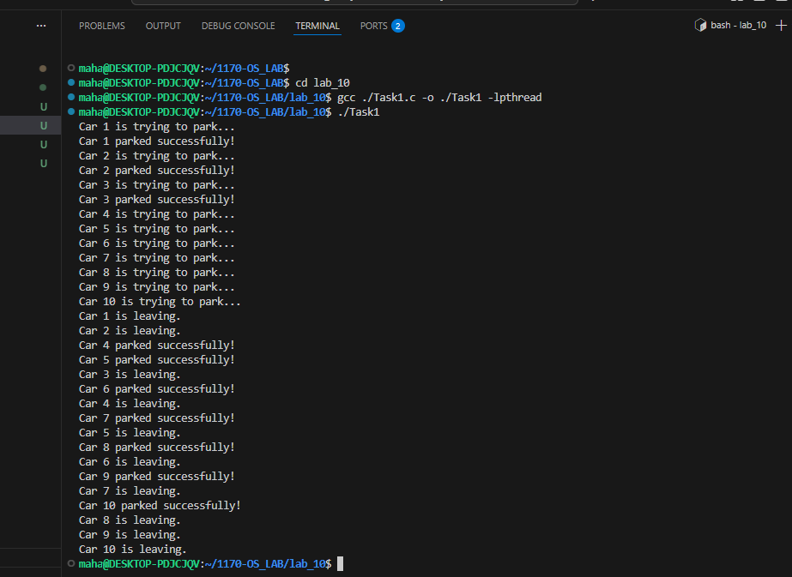
Task2:
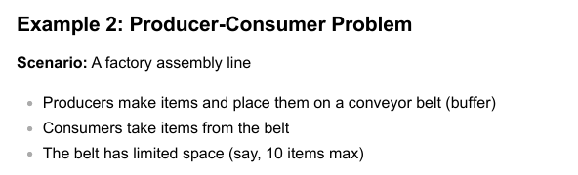
Code:
#include <stdio.h>
#include <pthread.h>
#include <semaphore.h>
#include <unistd.h>
#define BUFFER_SIZE 5
int buffer[BUFFER_SIZE];
int in = 0; // Producer index
int out = 0; // Consumer index
sem_t empty; // Counts empty slots
sem_t full; // Counts full slots
pthread_mutex_t mutex;
void* producer(void* arg) {
int id = *(int*)arg;
for(int i = 0; i < 3; i++) { // Each producer makes 3 items
int item = id * 100 + i;
// TODO: Wait for empty slot
sem_wait(&empty);
// TODO: Lock the buffer
pthread_mutex_lock(&mutex);
// Add item to buffer
buffer[in] = item;
printf("Producer %d produced item %d at position %d\n",
id, item, in);
in = (in + 1) % BUFFER_SIZE;
// TODO: Unlock the buffer
pthread_mutex_unlock(&mutex);
// TODO: Signal that buffer has a full slot
sem_post(&full);
sleep(1);
}
return NULL;
}
void* consumer(void* arg) {
int id = *(int*)arg;
for(int i = 0; i < 3; i++) {
// TODO: Students complete this similar to producer
sem_wait(&full);
pthread_mutex_lock(&mutex);
int item = buffer[out];
printf("Consumer %d consumed item %d from position %d\n",
id, item, out);
out = (out + 1) % BUFFER_SIZE;
pthread_mutex_unlock(&mutex);
sem_post(&empty);
sleep(2); // Consumers are slower
}
return NULL;
}
int main() {
pthread_t prod[2], cons[2];
int ids[2] = {1, 2};
// Initialize semaphores
sem_init(&empty, 0, BUFFER_SIZE); // All slots empty initially
sem_init(&full, 0, 0);
pthread_mutex_init(&mutex, NULL);
// No slots full initially
// Create producers and consumers
for(int i = 0; i < 2; i++) {
pthread_create(&prod[i], NULL, producer, &ids[i]);
pthread_create(&cons[i], NULL, consumer, &ids[i]);
}
// Wait for completion
for(int i = 0; i < 2; i++) {
pthread_join(prod[i], NULL);
pthread_join(cons[i], NULL);
}
// Cleanup
sem_destroy(&empty);
sem_destroy(&full);
pthread_mutex_destroy(&mutex);
return 0;
}

Terminal:
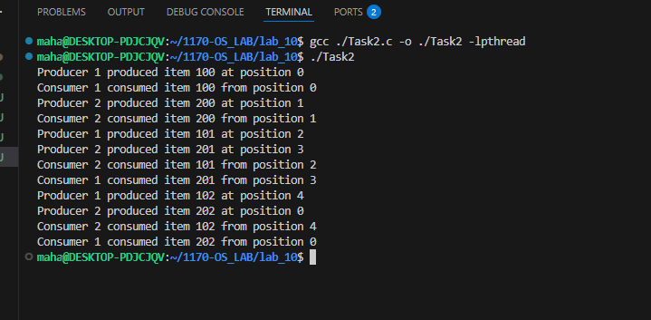
Reminders:
- The Buffer size initialized i.e. 5 and declared globally.
- The program has a shared buffer where producers put items means produce items and consumers take them out means consumes the items.
- Two counters, empty and full keep checking/ Tracking of how many spaces are empty or filled .
- A lock makes sure only one thread touches the buffer at a time.
- Producers wait if the buffer is full, then put an item inside.
- Consumers wait if the buffer is empty, then take an item out.
- Two producers and two consumers work at the same time without crashing into each other.

Part 2:
item = id * 100 + i
Each producer generates 3 items:
for i = 1, 2, 3.
When id = 1
Items:
- 1 × 100 + 1 = 101
- 1 × 100 + 2 = 102
- 1 × 100 + 3 = 103
When id = 2:
Items:
- 2 × 100 + 1 = 201
- 2 × 100 + 2 = 202
- 2 × 100 + 3 = 203
Total items produced = 6
items Values = 101, 102, 103, 201, 202, 203
Buffer and Blocking Explanation
- There are 5 buffers.
- Producers attempt to produce 6 items.
- The first 5 items fill the buffer.
- When the 6th item is produced, the producer blocks/waits because the buffer is full.
Consumer Situation
- Consumers expect 8 items, but producers generate only 6 items.
- Since two items never get produced, and producers are blocked waiting for buffer space that never frees, this results in a deadlock.
